* 1. **The Tangent Problem**
  2. **The Limit of a Function**

**The Tangent Problem (part 1)**

The population of a bacteria colony increases at a rate that is modeled by the function , where *x* represents time (and thus should be positive), and *y* represents population

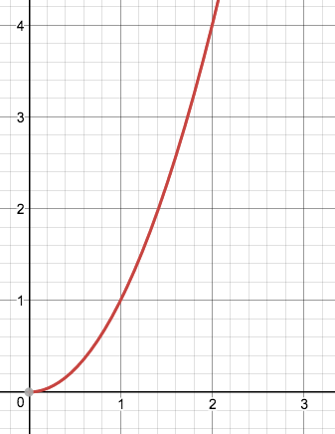What is the slope of the tangent line at *x* = 1?

What is the equation of the tangent at *x* = 1?

**Tangent Line –**

**Secant Line –**

**The Limit of a Function**

**Continuous Functions –**

 

 

 