**1.3 One-Sided Limits**

**Piecewise Functions –**

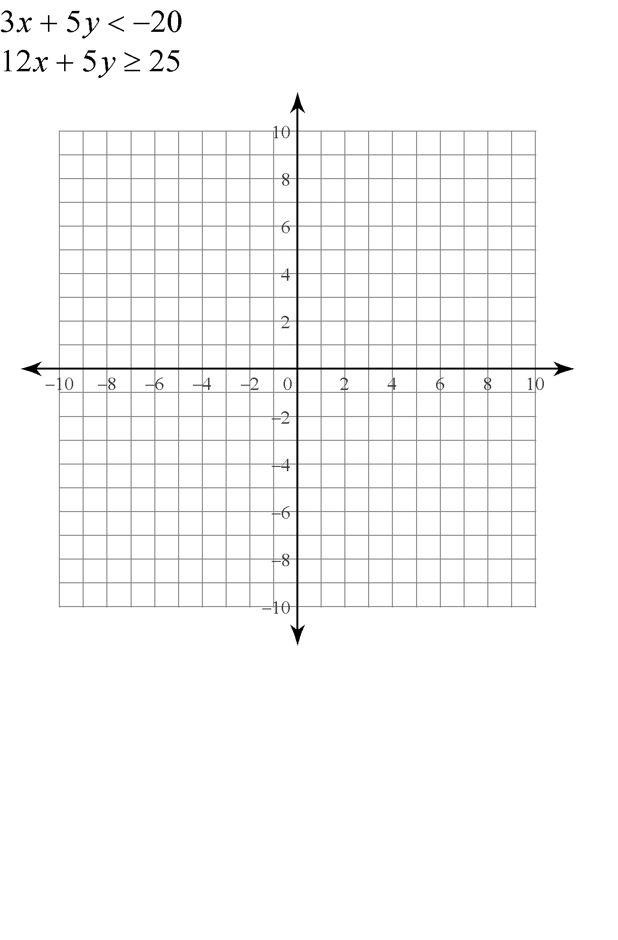





Left-hand limit –

Right-hand limit –



Determine whether  exists.

Determine whether exists.

Show that 

**Continuous Functions –**

Where is the following function discontinuous? 