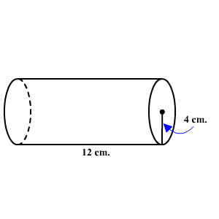**1.6 Surface Area and Volume of Cylinders, Cones, and Spheres**

**Cylinders**

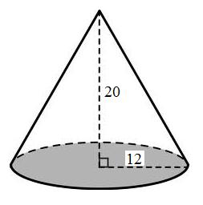

**Cones**

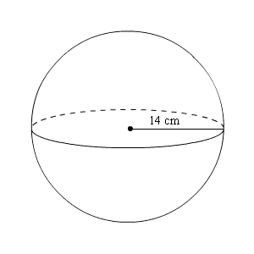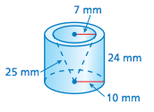**Spheres**

**Composite Shapes**