**1.8 Review**

**Properties of Limits (apply to one-sided limits as well)**

Suppose that the limits  and  both exist and let *c* be a constant. Then

1.   
     
   * the limit of a sum is the sum of the limits
2.   
     
   * the limit of a difference is the difference of the limits
3.   
     
   * the limit of a constant times a function is the constant times the limit of the function
4.   
     
   * the limit of a product is the product of the limits
5.  if   
     
   * the limit of a quotient is the quotient of the limits
6.  if *n* is a positive integer  
     
   * the limit of a power is the power of the limit
7.  if the root on the right side exists  
     
   * the limit of a root is the root of the limit (if the root exists)

**Discontinuities**

The function *f* is continuous at  if

1.  exists
2.  exists, and
3. 

There are three types of discontinuities:

1. **Removable Discontinuity –**
2. **Jump Discontinuity –**
3. **Infinite Discontinuity –**

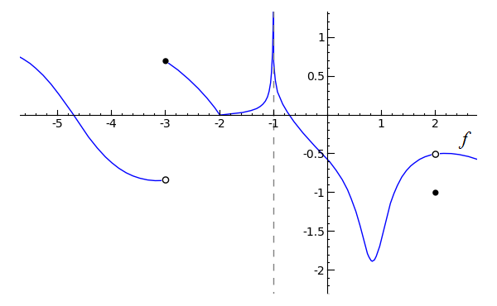Where are the discontinuities in this function? Why is it discontinuous there? What type of discontinuity is it?