**2.1 Derivatives**

The derivative of a function *f* at a number *a* is: 

Or, alternatively: 

**Geometric Interpretations of the derivative:**

1. **Slope of a tangent –**
2. **Rate of Change –**

**The Derivative as a function –**

Given a function *f*, the derivative of *f* is the function *f*’ defined by

Use the given graph of *f* to sketch the graph of *f*’.

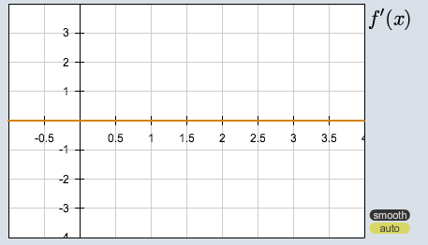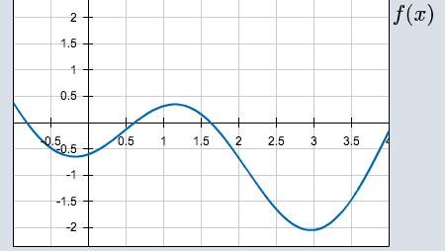

Ways to denote the derivative of 

Ways to denote the value of a derivative at a specific number *a*

If , find . Then use it to find 

**Differentiable Functions –**

Easy to tell from a graph where a function is NOT differentiable: