2.1 The Fundamental Counting Principle (continued)

Bill owns 5 shirts and 3 sweaters. How many options does Bill have if he chooses:
- 1 shirt AND 1 sweater?

- 1 shirt OR 1 sweater?

A standard deck of cards contains 52 cards. Count the number of possibilities of
- drawing two cards and getting a black face card AND an ace

- drawing one card and getting either a black face card OR an ace

- drawing one card and getting either a red card OR a 10

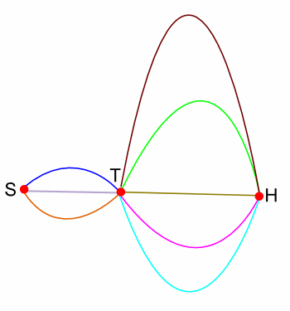
How many ways are there of getting from S to H, passing through each point at most once?

How many numbers can be made using the digits 4, 6, and 8?

How many even four-digit numbers have no repeated digits?

