**2.3 The Sum and Difference Rules**

**Sum Rule**

If both *f* and *g* are differentiable, then so is *f* + *g* and







**Difference Rule**

If both *f* and *g* are differentiable, then so is *f* – *g* and





Differentiate the following:

 

 

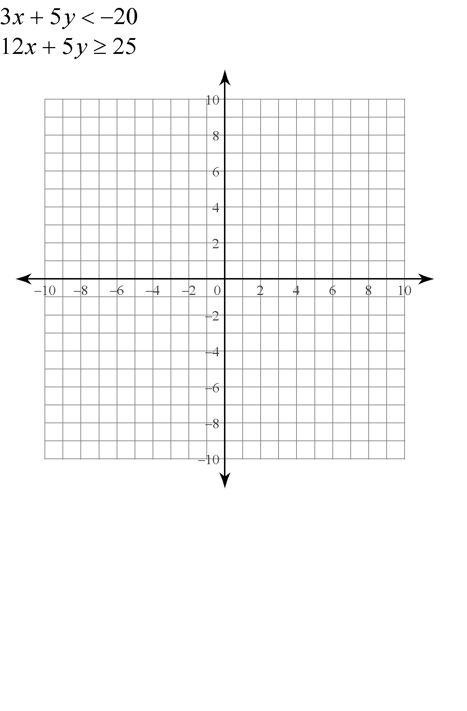Find the equations of both lines that pass through the point P and are tangent to the parabola . Provide a sketch of the parabola and the tangents.