**4.1 Increasing and Decreasing Functions (continued)**

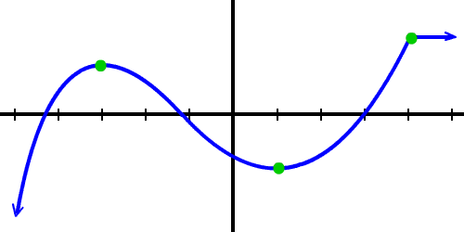

A function *f* is called **increasing on an interval I** if:

A function *f* is called **decreasing on an interval I** if:

How can the derivative of a function tell us where a function is increasing or decreasing?

Find the intervals on which the function  is increasing and decreasing.

Find the intervals of increase and decrease for the function 