**4.2 Logarithmic Functions and their Graphs (continued)**

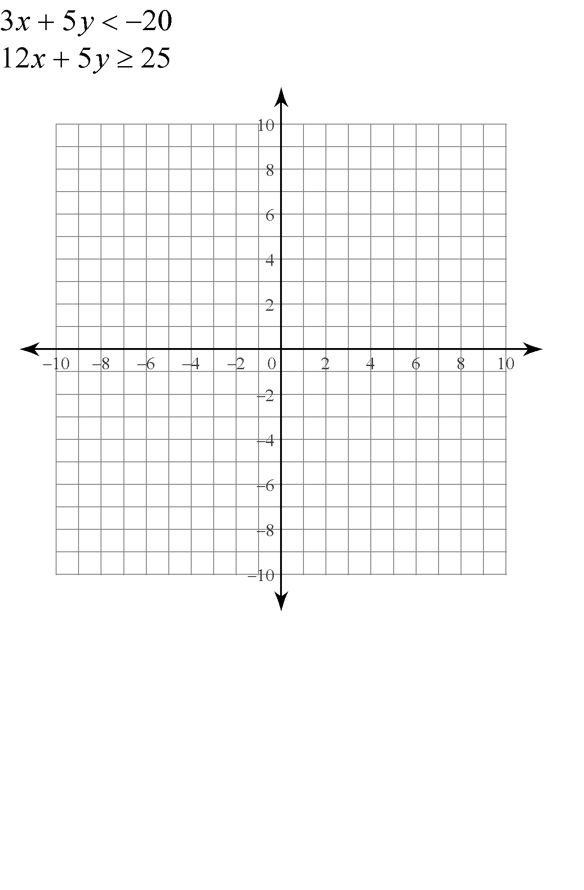

|  |  |  |  |  |  |
| --- | --- | --- | --- | --- | --- |
| **Function** | **Domain** | **Range** | ***x*-intercept** | ***y*-intercept** | **Asymptote** |
|  |  |  |  |  |  |
|  |  |  |  |  |  |

**Logarithmic Graphs**



**Graph**: 

**Determine the domain of the following logarithmic functions**

  

**Determine the inverse of the following:**

 