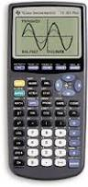**4.5 Graphing with a Calculator**

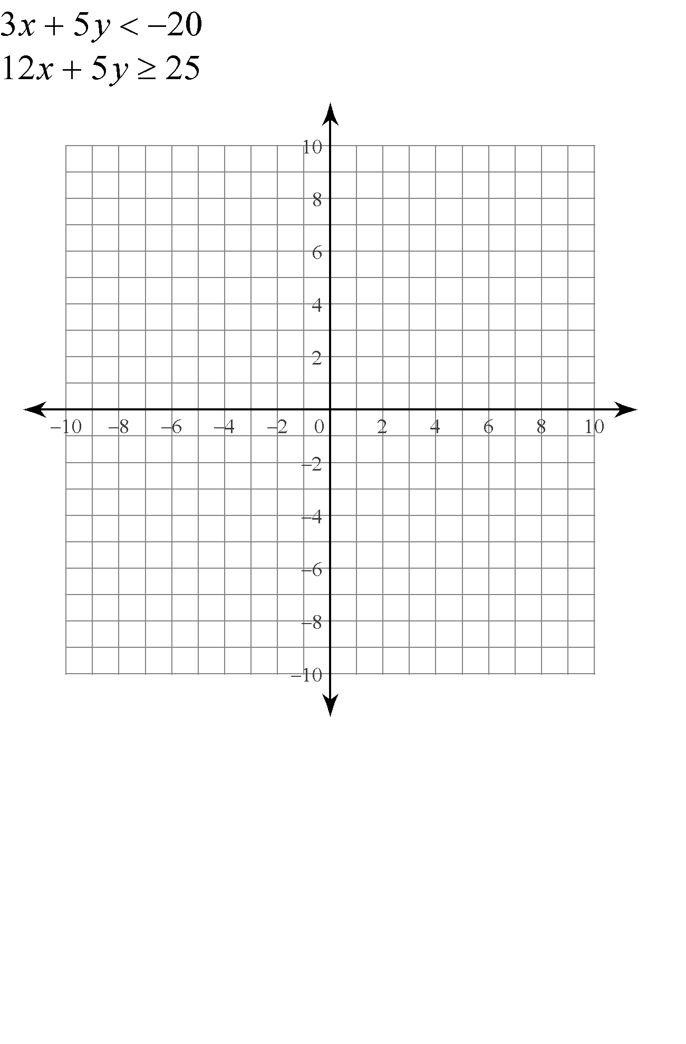Graph 

Graph 



Graph 

Graph 