Practice Test Foundations and Pre-Cal 10

- Is each relation linear or non-linear? Explain your choice.
  - The orbit of a planet around the sun on an elliptical path in terms of time and distance of the planet from the sun
  - (-10,-5), (-5,0), (0,5), (5,10)
  - y=2x²+3x-1
X | Y
82 | 16
91 | 20
100 | 25
109 | 31
118 | 38

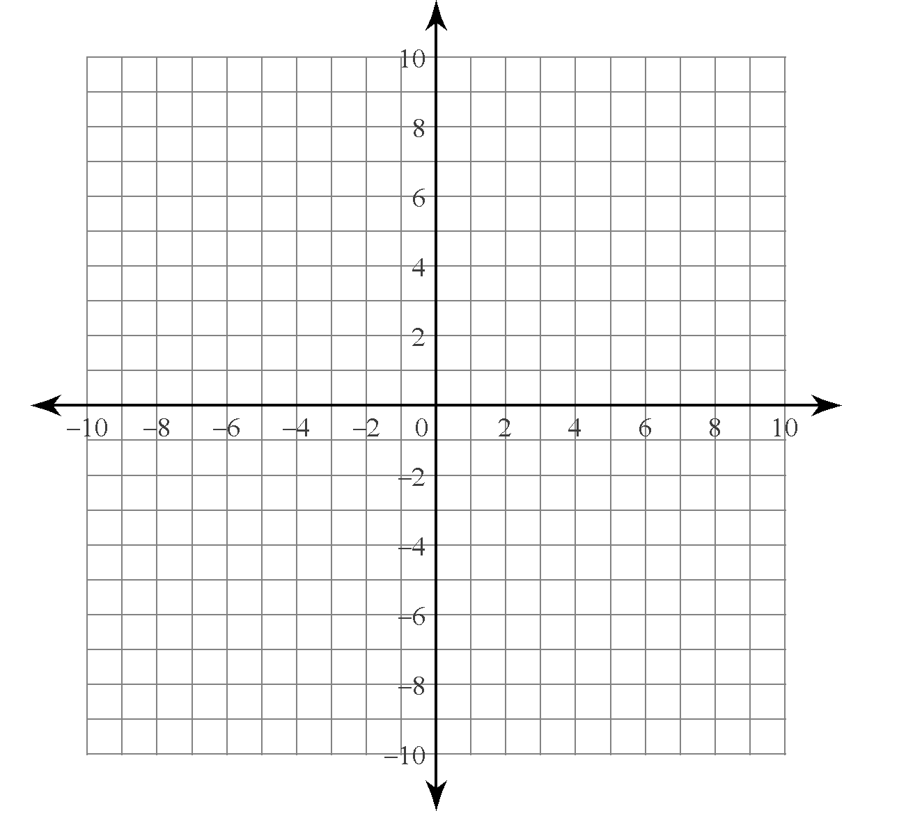

- Which of the following represent the same relation?
X | Y
-2 | 0
0 | 2
2 | 4
4 | 6
A B

C One number is double another
D (-2,0), (0,2), (2,4), (4,6)

- Katya wants to sell a camper trailer. The cost to place an advertisement in a newspaper is $37.95 for three lines of text and a picture plus $7 for each additional line of text. Consider the relation of total cost vs. total number of lines of text,
  - Is this relation linear? Explain
  - Identify the dependent and independent variable
  - Create a set of ordered pairs to represent 3,4,5,6, and 7 lines of text in the advertisement
  - Is this relation discreet or continuous?
  - Graph the relation
- State the domain and range of each relation
  - (-9,5), (-5,5), (0,5), (0,8), (2,8)

- Express the domain and the range of each relation in interval notation and set notation.

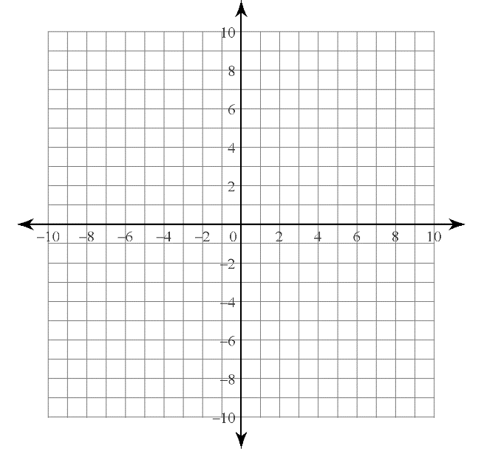

X | Y
1 | 1
2 | 2
3 | 3
4 | 4
5 | 5
- Which relations are functions? Explain how you know.

Hair color | Gender
Brown | Male
Black | Male
Black | Female
Blonde | Female
Red | Female

  - (2.3,5.1), (8.6,9.4), (8.6,9.2), (9.5, 10.0)
- The function M(E)=E/2.7 can be used to approximate your weight, M, in Kg, on mars where , E, in Kg, is your weight on earth.
  - Suppose you weight 66Kg on earth, how much would you weight on mars?
  - How much would a Martian who weighs 14Kg on mars weight on earth?
- For her local run for the cure Amber donates $50 of her own money she also collects $25 pledges. The function P(n)=25n+50 represents the total funds she contributes
  - Determine an appropriate domain and range the use a table of values to graph the function.
  - Determine the value of P(8). Explain the meaning of your answer.
  - Prizes are awarded to students who collect more than $675. How may pledges must Amber collect to receive a prize?
  - Explain why this situation depicts a function.

