**5.0 Review**

**Even Functions –**

**Odd Functions –**

Determine whether the following functions are odd, even, or neither

 

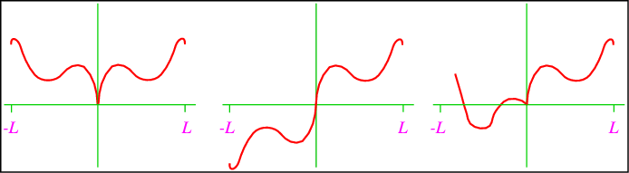

**Intercepts –**

Find the intercepts of the following curves:

 

**Dividing Polynomials**

 

**Vertical Asymptotes –**

**Horizontal Asymptotes –**

Find the asymptotes for 