**5.1 Vertical Asymptotes**

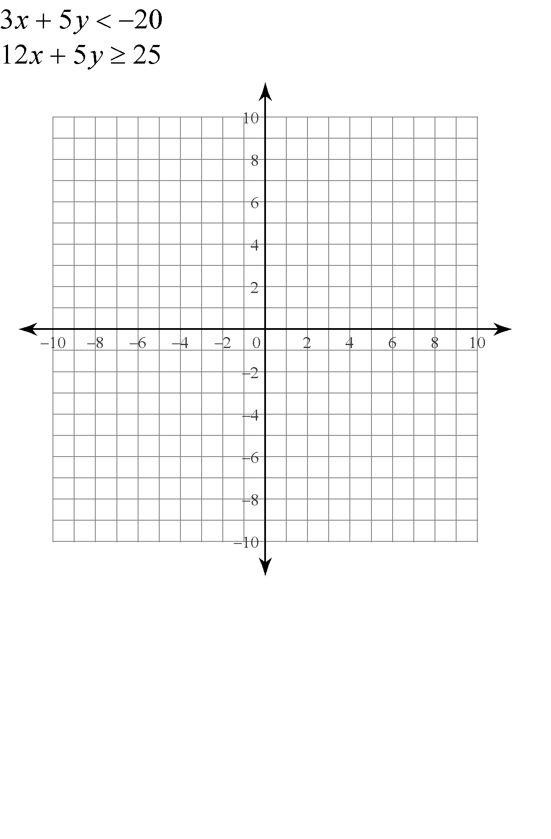

**Infinite Limit –**





**One-Sided Infinite Limits**

Find  and 

Find 

Find the vertical asymptotes of  and sketch its graph near the asymptotes.