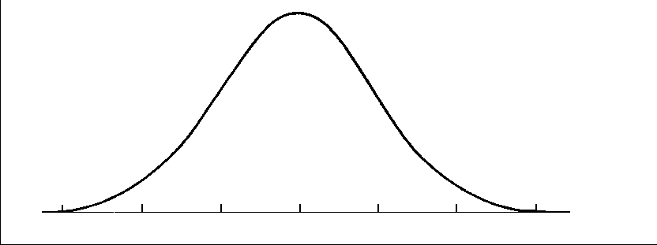
5.3 The Normal Distribution (Part A)

normal curve

Ex. Sketch the following normally distributed samples:
 | Weight of Luggage |  |  | Weight of Luggage
Team | μ (kg) | σ (kg) |  | μ (kg) | σ (kg)
Men | 6.35 | 1.04 |  | 5.8 | 0.83
Women | 6.35 | 0.59 |  | 3.9 | 0.83

Ex. Jim raises Siberian husky dogs. The weights of adult dogs are normally distributed with a mean of 52.5 lbs and a standard deviation of 2.4 lbs. What % of dogs would you expect to have a weight between 47.7 lbs and 54.9 lbs?

Ex. Does the following data (showing the longevity of cell phones, in years) approximate a normal distribution?
2.0 2.4 3.3 1.7 2.5 3.7 2.0 2.3 2.9 2.2
2.3 2.7 2.5 2.7 1.9 2.4 2.6 2.7 2.8 2.5
1.7 1.1 3.1 3.2 3.1 2.9 2.9 3.0 2.1 2.6
2.6 2.2 2.7 1.8 2.4 2.5 2.4 2.3 2.5 2.6
3.2 2.1 3.4 2.2 2.7 1.9 2.9 2.6 2.7 2.8

Age of Phone | Frequency

