**5.4 Graphing Basic Trigonometric Functions (part 3)**

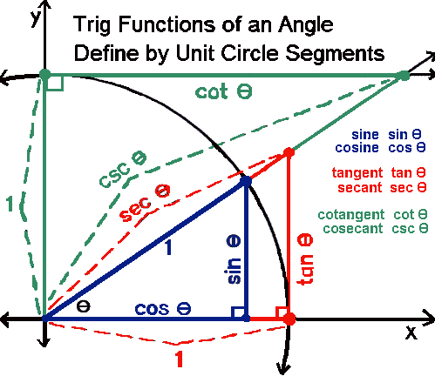

|  |  |  |  |  |  |  |  |  |  |  |  |  |  |  |  |  |  |  |  |
| --- | --- | --- | --- | --- | --- | --- | --- | --- | --- | --- | --- | --- | --- | --- | --- | --- | --- | --- | --- |
|  |  |  |  |  |  |  |  |  |  |  |  |  |  |  |  |  |  |  |  |
|  |  |  |  |  |  |  |  |  |  |  |  |  |  |  |  |  |  |  |  |
|  |  |  |  |  |  |  |  |  |  |  |  |  |  |  |  |  |  |  |  |
|  |  |  |  |  |  |  |  |  |  |  |  |  |  |  |  |  |  |  |  |
|  |  |  |  |  |  |  |  |  |  |  |  |  |  |  |  |  |  |  |  |
|  |  |  |  |  |  |  |  |  |  |  |  |  |  |  |  |  |  |  |  |
|  |  |  |  |  |  |  |  |  |  |  |  |  |  |  |  |  |  |  |  |
|  |  |  |  |  |  |  |  |  |  |  |  |  |  |  |  |  |  |  |  |
|  |  |  |  |  |  |  |  |  |  |  |  |  |  |  |  |  |  |  |  |
|  |  |  |  |  |  |  |  |  |  |  |  |  |  |  |  |  |  |  |  |

Determine the period and the phase shift (and any other transformations) for each of the following:

 

Graph and state the domain, range and period.

|  |  |  |  |  |  |  |  |  |  |  |  |  |  |  |  |  |  |  |  |
| --- | --- | --- | --- | --- | --- | --- | --- | --- | --- | --- | --- | --- | --- | --- | --- | --- | --- | --- | --- |
|  |  |  |  |  |  |  |  |  |  |  |  |  |  |  |  |  |  |  |  |
|  |  |  |  |  |  |  |  |  |  |  |  |  |  |  |  |  |  |  |  |
|  |  |  |  |  |  |  |  |  |  |  |  |  |  |  |  |  |  |  |  |
|  |  |  |  |  |  |  |  |  |  |  |  |  |  |  |  |  |  |  |  |
|  |  |  |  |  |  |  |  |  |  |  |  |  |  |  |  |  |  |  |  |
|  |  |  |  |  |  |  |  |  |  |  |  |  |  |  |  |  |  |  |  |
|  |  |  |  |  |  |  |  |  |  |  |  |  |  |  |  |  |  |  |  |
|  |  |  |  |  |  |  |  |  |  |  |  |  |  |  |  |  |  |  |  |
|  |  |  |  |  |  |  |  |  |  |  |  |  |  |  |  |  |  |  |  |
|  |  |  |  |  |  |  |  |  |  |  |  |  |  |  |  |  |  |  |  |