**6.0 Review of Trigonometry**

**Radian –**

Converting Degrees to Radians –

Ex. 240° =

Converting Radians to Degrees –

Ex.  =

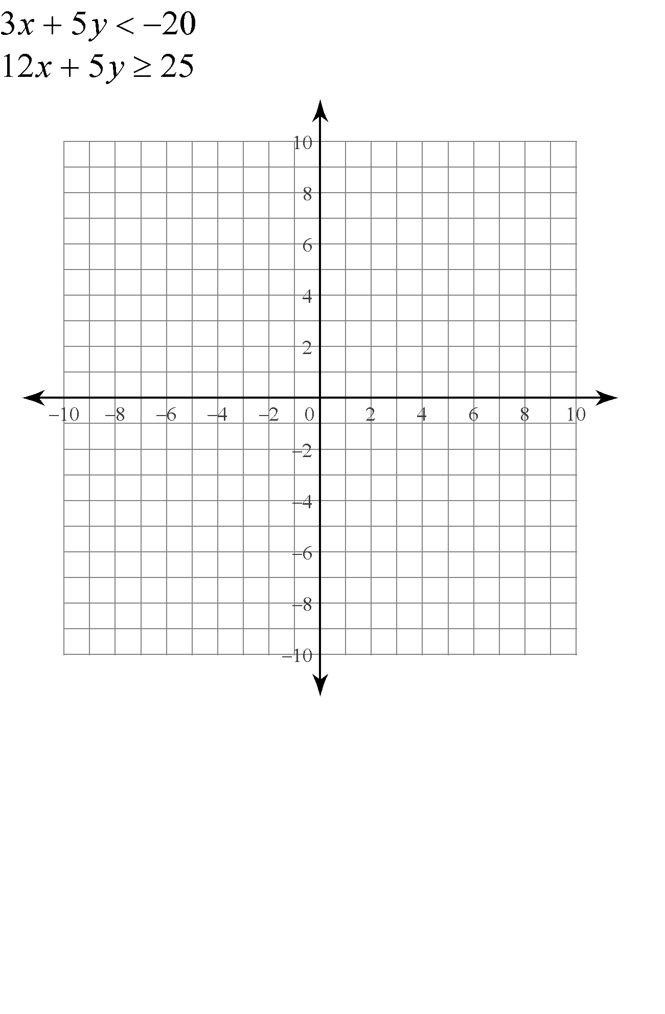**Standard Position Angles –**

**Coterminal Angles –**

Ex. Give two positive and two negative angles that are coterminal to 

**Reference Angles –**

Ex. Give the reference angle for each of the following standard position angles

200° = 12.3° =  =  =

**Special Triangles and Special Angles**

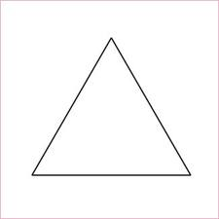45˚ - 45˚ - 90˚ triangle 30˚ - 60˚ - 90˚ triangle

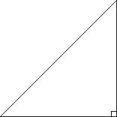

|  |  |  |  |  |  |
| --- | --- | --- | --- | --- | --- |
|  | **0˚** | **30˚** | **45˚** | **60˚** | **90˚** |
| **sin** |  |  |  |  |  |
| **cos** |  |  |  |  |  |
| **tan** |  |  |  |  |  |
| **csc** |  |  |  |  |  |
| **sec** |  |  |  |  |  |
| **cot** |  |  |  |  |  |

Evaluate the following (give exact answers):

 =   =

Given the point  on the terminal side of angle , determine the value of all 6 trigonometric functions.

Find all angles *x*, such that and 