**7.1 Quadratic Functions (part 3)**

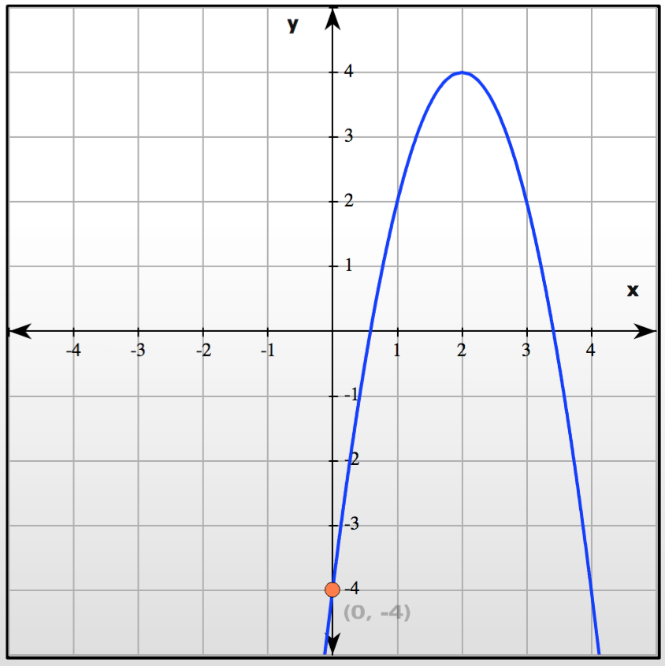Find the equation of the following parabola:

Find the equation of a parabola that has its vertex at (5, 2) and a y-intercept at -3.