**7.2 Derivatives of the Sine and Cosine Functions**

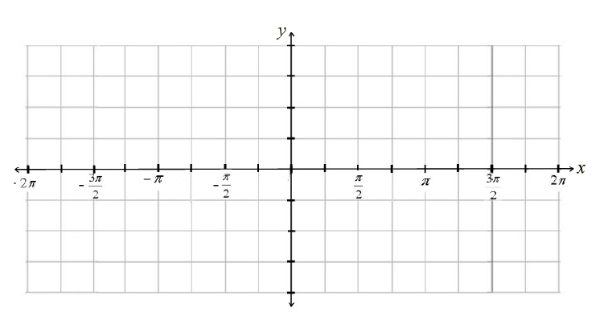**The Derivative (**) –

 

Differentiate the following:

  

  

Solve by implicit differentiation: 

Find the equation of the tangent line to  at the point where 