8.1 Sine, Cosine, and Tangent for Right Triangles

Trigonometry –

Right triangle

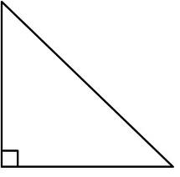

Ratios in Right Triangles

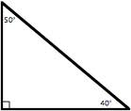

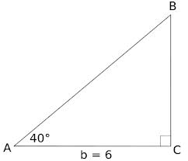
Solve the following triangle

