9.0(a) Cumulative Review for Chapters 1 – 3

Evaluating Limits
$\lim_{x→3}{\frac{2x^{2}-5x-3}{x-3}}$ $\lim_{x→2}{\frac{x^{4} - 16}{x-2}}$

$\lim_{x→0}{\frac{\sqrt{X+4 }-2}{x}}$ $\lim_{x→-4^{+}}{\frac{3x-1}{x+4}}$

Find $\lim_{x→6-}{f(x)}$, $\lim_{x→6+}{f(x)}$, and $\lim_{x→6}{f(x)}$, if they exist.

- $f\left(x\right)=\left\{\begin{aligned}x+2, x<2 \\ 2, 2 ≤x ≤6 \\ 14-2x, x>6\end{aligned}\right.$ b) $f\left(x\right)=\left\{\begin{aligned}4\left(x-1\right), x<6 \\ x^{2}-12, x≥6\end{aligned}\right.$

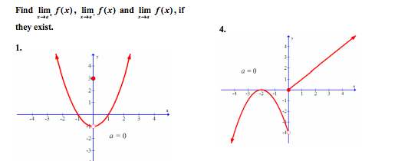

Find the derivative of the following functions directly from the definition of a derivative
- $y=2x^{2}+3x$ b) $y=\sqrt{x+3}$

The position of a particle is described by the function $s\left(t\right)=t^{3}-6t^{2}+9t$.
- When is the particle at rest?

- What is the velocity after 2 seconds?

- What is the acceleration after 3 seconds?
- When is the velocity positive and when is it negative?
- What is the total distance traveled during the first 5 seconds?

