Chapter 1 (part b) Practice Test

- Given the graph of the function y=f(x), sketch the graph of each transformed function.
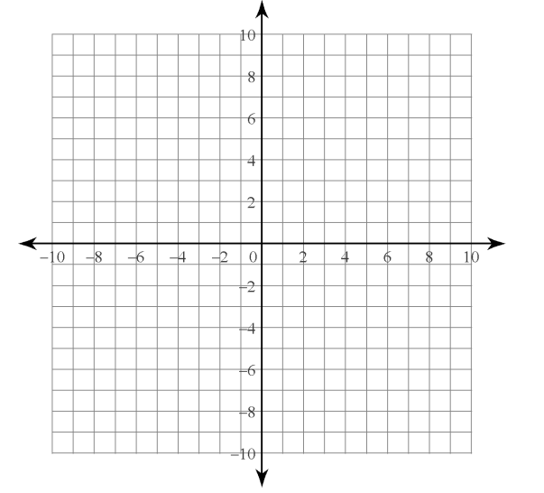
- y-3=f(x)
- h(x)=f(x+1)
- y+1=f(x-2)

- Describe how to translate the graph of y=│x│ to obtain the graph of the function shown. Write the equation of the transformed function in the form y-k=│x-h│.

- The range of the function y=f(X) is {y│-2<y<5, y € R}. What is the range of the function y=f(x-2)+4?

- James wants to explain vertical and horizontal translations by describing the effect of the translation on the coordinates of a point on the graph of a function. He says, “If the point (a,b) is on the graph of y=f(x), then the point (a-5,b+4) is the image point on the graph of y+4=f(x-5).” Do you agree with James? Explain your reasoning.

- Name the line of reflection when the graph of y=f(x) is transformed as indicated then state the coordinates of the image point of (3,5) on the graph of each reflection.
- y=-f(x)
- y=f(-x)

- Copy each graph of y=f(x) then,
  - Sketch the reflection indicated
  - state the domain and range of the transformed function
  - List any invariant points
- y=f(-x) b) y=-f(x)

- a) Sketch the graphs of the functions f(x)=x², g(x)=f(2x) and h(x)=f(1/2x) on the same set of coordinate axes.
b) Describe how the value of the coefficient of x for g(x) and h(x) affects the graph of the function f(x)=x².
- Consider the graphs of functions f(x) and g(x).
- Is the graph of g(x) a horizontal or vertical stretch of the graph of f(x)? Explain your reasoning.
- Write the equation that models the graph of g(x) as a transformation of the graph of f(x).

- Given the graph of y=f(x) sketch the graph of each transformed function
- y=2f(1/2x)
- y=1/2f(3x)

- Explain how the transformations described by y=f(4(x+1)) and y=f(4x+1) are similar and how they are different.
- Write the equation for the graph of g(x) as a transformation of the equation for the graph of f(x).

- Consider the graph for y=f(x). Sketch the graph of each transformation.
- y=1/2f(-(x+2))
- y-2=-f(2(x-3))
- y-1=3f(2x+4)

