Foundations 11
Practice Test
- Solve the following quadratic equation by graphing the corresponding quadratic function
$$0=x^{2}-4x-5$$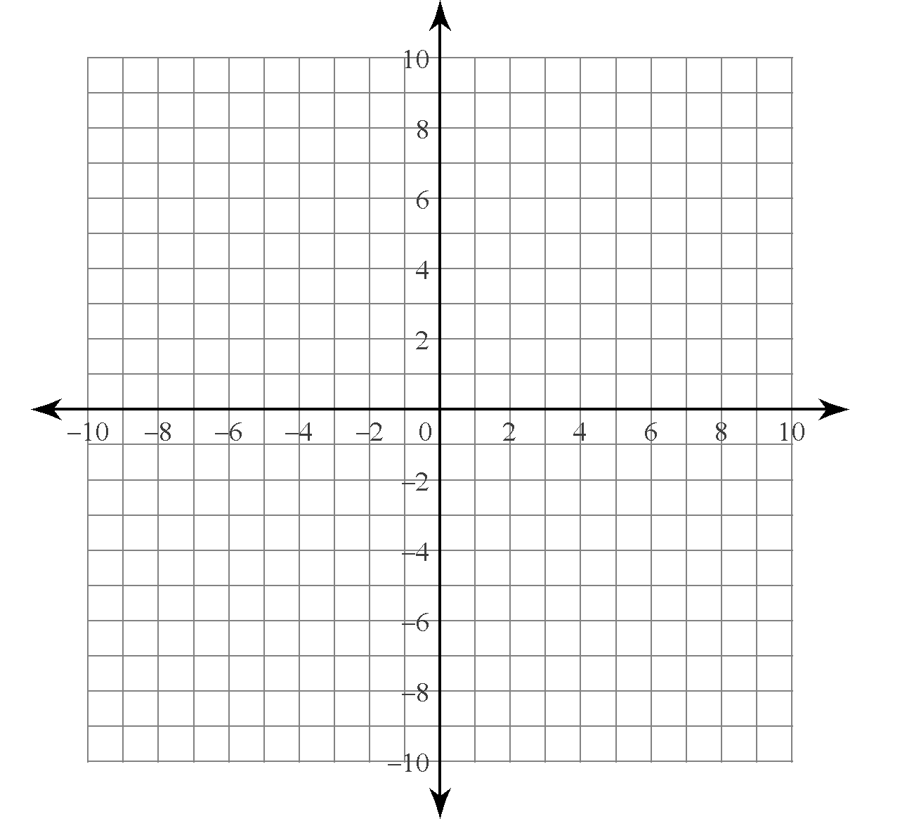
- Solve by factoring. Check your solutions.
a) $0= x^{2}+10x+21$
b) $\frac{1}{4}m^{2}- 2m-5=0$
c) ${5p}^{2}+13p-6=0$
d) $0={6z}^{2}-21z+9$
- The path of a paper airplane can be modelled approximately by the function
$h\left(t\right)= -\frac{1}{4}t^{2}+t+3$, where h is the height above the ground, in metres, and t is the time of flight, in seconds. Determine how long it takes for the paper airplane to hit the ground, h(t) = 0.
- The length of the base of a rectangular prism is 2m more than its width, and the height of the prism is 15.
a) Write an algebraic expression for the volume of the rectangular prism.
b) The volume of the prism is 2145$m^{3}$. Write an equation to model the situation.
c) Solve the equation in part b) by factoring. What are the dimensions of the base of the rectangular prism?
- Solve using square roots. Express your answers as exact values.
a) ${2x}^{2}-98=0$
b) $(x+3)^{2}=25$
c) ${(x-5)}^{2}=24$
d) ${(x-1)}^{2}= \frac{5}{9}$

- Use the quadratic formula to determine the roots for each quadratic equation. Express your answers as exact values.
a) ${-3x}^{2}-2x+5= 0$
b)${ 3x}^{2}-4x-1=0$
c) ${25x}^{2}+90x+81=0$

- The length of the hypotenuse of a right triangle is 1cm more than triple that of the shorter leg. The length of the longer leg is 1cm less than triple that of the shorter leg.
a) Sketch and label a diagram with expressions for the side lengths.
b) Write an equation to model the situation.
c) Determine the lengths of the sides of the triangle.

- A rectangular piece of paper has a perimeter of 100cm and an area of 616${cm}^{2}$. Determine the dimensions of the paper.

