Pre-Calculus 10
Practice Test

- What are the slope and y-intercept of each line?
- y = -5x +6 b) 5x – 6y +12 = 0

- Write the equation of the line with each slope and y-intercept. Explain your steps.
- Slope$=-{\frac{1}{2}},$y-intercept = 6 b) slope = 0, y-intercept = -6

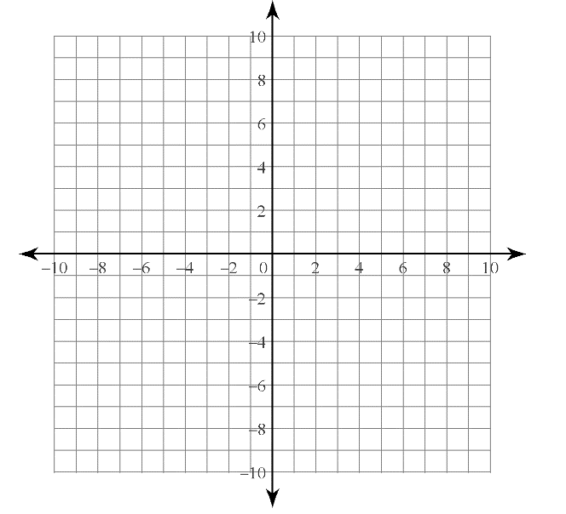
- State the intercepts of each line as ordered pairs. Then, write the equation of each line in standard form.
- b)

- What are the x-intercepts and y-intercepts of each line? Use the intercepts to sketch a graph of each line.
- 5x – 2y – 20 = 0
- y = 4

- Use slope-point form to write an equation of a line through each point with the given slope. Express each answer in slope-intercept form and in standard form.
- (-2, 1) and m = 4 b) (8, -3) and m =${\frac{1}{2}}$

- Explain how you would use slope-point for to write and equation of a line through points (1, 10) and (3, 2). Then, express the equation in slope-intercept form and in standard form.

- At higher altitudes, water boils at a lower temperature because the air pressure is lower. Suppose water boils at 96.5 °C at an altitudes of 1000m, and at 93.0 °C at an altitude of 2000m.
- What is the slope of the line representing the data? What rate does the slope represent?
- Write an equation of the line. Express your answer in slope-intercept form or in standard form.
- Mountain climbers need to adjust their ingredients and cooking techniques when cooking at higher altitudes. What is the boiling temperature of water an elevation of 4000 m?

- Write an equation of a line through (-1, 2) and parallel to y = -7. Explain your reasoning.

- Write an equation of a line through (-6, 7) and perpendicular to 3x + 4y -12 = 0. Explain your reasoning.

- How could you determine the equation of a line perpendicular to 2x + 5y +10 = 0 with the same x-intercept as 3x – 2y = 12?

