**0.4 Review of Pre-Calculus (part 4)**

**Functions**

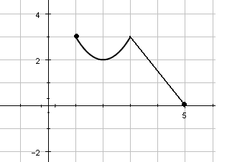

Is this graph a function? How do you know?

Is this graph a one-to-one function? How do you know?

State the domain (in two ways).

State the range (in two ways).

Evaluate *f* at the following values of *x*:

a)  b)  c) 

If , find:

a)  b) 

**Even Functions –**

**Odd Functions –**

Determine whether the following functions are odd, even, or neither (also try the two functions on the first side of the page):

a)  b) 

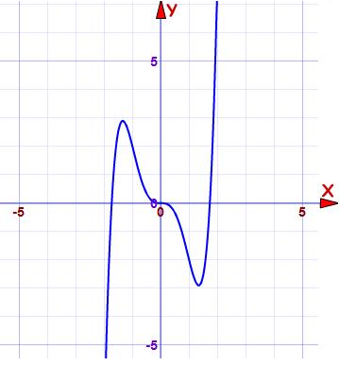 c) d)

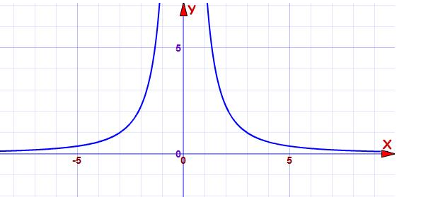

**Equations of Lines**

Find an equation (in general form) of the line with the following characteristics:

1. perpendicular to , passing through the point 
2. passing through , *x*-intercept of 6