**0.5 Review of Pre-Calculus (part 5)**

**Operations on Functions**

If  and , find the following:

a)  b) 

c)  d) 

**Composite Functions**

If  and , find the following:

a)  b) 

c)  d) 

**Inverse Functions**

Find the inverse of the following:

a)  b) 

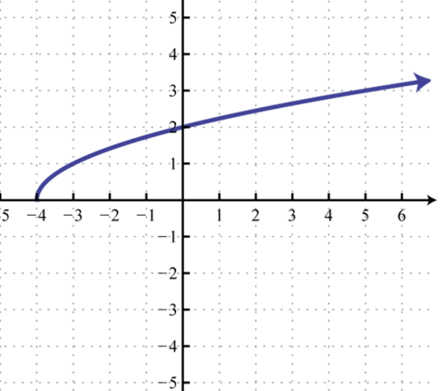 c)

**Absolute Value as Interval Notation**

Steps: (1)

(2)

(3)

a) [2, 10] b)  or 